**FINTECH CASE STUDY**

**PAYSLIP FRAUD DETECTION USING MACHINE LEARNING AT COMMONWEALTH BANK**

**OF AUSTRALIA**

**Business Profile: Commonwealth Bank Australia**

Commonwealth Bank of Australia (CBA) is Australia's leading providers of combined financial services, providing retail, business and institutional banking, funds management, superannuation, life insurance, general insurance, broking services and finance company activities. Their operations are conducted primarily in Australia and New Zealand. In addition, overseas branches operate in a number of other countries, including the United Kingdom, the United States, China, Japan, Singapore, Hong Kong, Indonesia and South Africa. CBA currently provides well diversified financial services to the global financial sector. They are;

**Retail Banking Services:**  Retail Banking Services provides banking and general insurance products and services to personal customers. Retail Banking Services also includes the financial results of retail banking activities provided under the Bankwest brand.

**Business and Private Banking:**  Business and Private Banking serves the banking needs of business, corporate and agribusiness customers across the full range of financial services solutions as well as providing banking and advisory services for high net worth individuals. It also provides equities trading and margin lending services through the CommSec business. Business and Private Banking also includes the financial results of business banking activities conducted under the Bankwest brand.

**Institutional Banking and Markets:**  Institutional Banking and Markets serves the commercial and wholesale banking needs of large corporate, institutional and government clients across a full range of financial services solutions including access to debt capital markets, transaction banking, working capital and risk management through dedicated product and industry specialists.

**Wealth Management:** Wealth Management provides superannuation, investment and retirement products.

**New Zealand:** New Zealand includes the banking and funds management businesses operating in New Zealand primarily under the ASB brand. ASB provides a range of banking, wealth and insurance products and services to its personal, business, rural and corporate customers in New Zealand.

**International Financial Services and Corporate Centre:** International Financial Services (IFS) include the Indonesian retail and business banking operations (PT Bank Commonwealth), and minority investments in China (Bank of Hangzhou and Qilu Bank) and Vietnam (Vietnam International Bank).

**Company Profile: Commonwealth Bank of Australia**

|  |  |
| --- | --- |
| **Commonwealth Bank of Australia** | |
| Market Capitalisation | 174,530,592,000 |
| Total shares quoted | 1,706.400,000 |
| Last close trading price | $102.28 |
| GICS Sector: | Financial |
| GICS Industry Group: | Banks |
| GICS Industry: | Banks |
| Number of employees: | 47,532 (2021) |
| Total Revenue | $30,160,000,000 (2020) |
| Market Capitalisation: | $174,530,000,000 |
| Listed stock exchange | Australian Stock Exchange |
| Listing date | 12/09/1991 |
| Overseas stock exchanges | London and Munich stock exchanges |
| Headquarters Sydney | New South Wales, Sydney |
| Auditors | PricewaterhouseCoopers |
| CEO: Matthew Comyn | (since 9/4/2018) |
| Early Founders: | Andrew Fisher King O’Malley |
| Founded | 4/9/1911 |

Source: CBA Annual Report 2021

|  |  |  |
| --- | --- | --- |
|  |  |  |

**The main competitors of Commonwealth Bank of Australia**

The main competitors of CBA are NAB, WBC and ANZ banks. As a market leader based on overall market capitalisation CBA holds the market share of 41% while, NAB, WBC and ANZ banks hold 23%, 20% and 16% respectively. However, these banks have different market share positions based on total number of domestic and overseas branches, automated teller machines, number of depositors and loans, banks focus of shifting to digital channels, increasing focus on internet and mobile banking and payment transactions etc.

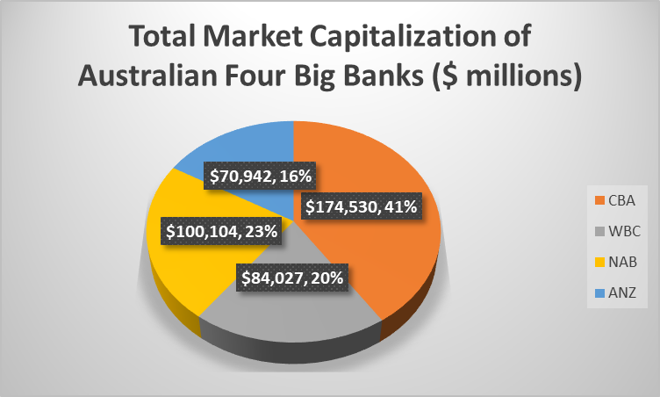

**How does Commonwealth Bank Australia use technology to its advantage? Why are they considered a Fin Tech Company?**

The banking industry in next decade will look very different from what it looks like today. Some clients will opt for an autonomous banking experience when they are poor in time, lack of knowledge and have high levels of trust in their bank to do the right thing and have the confidence in their digital competence to do what they promise they will do. It will be their choice and the winning Bank of the future will be adaptive to their customers dynamic needs and wants. The market leading banks of tomorrow will understand that technology will not limit what is possible. Banks make use digital capability to put their customers firmly in control of their destination and preferred model for dealing with their bank and other financial service providers.

KPMG have partnered with the Commonwealth Bank of Australia and submitted The Future of Digital Banking Report. This report is designed to stimulate thinking about how the banking industry can be smarter and better, positively impacting to meets it customers changing needs and wants and enhance their financial wellbeing. KPMG has looked 15 years into the future through our Emerging Technology systems and identified the following eight technological developments and capabilities as having the greatest potential impact on the bank-customer relationship by 2030.

|  |  |
| --- | --- |
| **Eight Emerging Financial Technologies**  **(FINTECH)** | |
| **Artificial Intelligence (AI) and Machine Learning (ML)** | AI and ML will automate tasks currently requiring human intelligence, resulting in customer service being transformed, immense quantities of data produced by IoT being analysed, and enhanced security. |
| **Distributed Ledger Technology (DLT) / Blockchain** | DLT will decentralise the management of customer transaction data, providing a more open platform; while blockchain will ensure that historic transactions will never be able to be altered, forcing transparency across all businesses who service the customer. |
| **Biometrics** | Passwords and PINs will cease to exist, replaced with biometrics like facial and voice recognition, enabling constant, real-time user identity validation and advanced behavioural profiling. |
| **5G** | Super-fast mobile internet will have the potential to reach over 1 gigabyte per second downloads, vastly improving the user experience and delivery of services in real time. |
| **Cloud Computing** | Cloud computing will remove the hardware burden on data storage and processing, allowing the bank to provide everyday consumers with immense data processing capabilities, accessible from any internet-enabled device. |
| **Internet of Things (IoT)** | Everyday objects will gain the ability to connect to the internet and produce data, far beyond the smart speakers and wearables of today, allowing products and services to be highly personalised, and all aspects of a consumer’s life to become frictionless. |
| **Augmented Reality (AR) / Virtual Reality (VR)** | Will allow banks to display rich information in the real world to help customers to make decisions more effectively, and become more accessible to those who may not be able to visit a branch. |
| **Quantum Computing** | Will be the enabler of processing vast volumes of data made available through IoT, and will also help AI and ML learn faster in their goal to automate manual tasks. |
|  |  |

Source: The- future- of- digital- banking- KPMG-CBA-report (2019)

The Future of Digital Banking- CBA

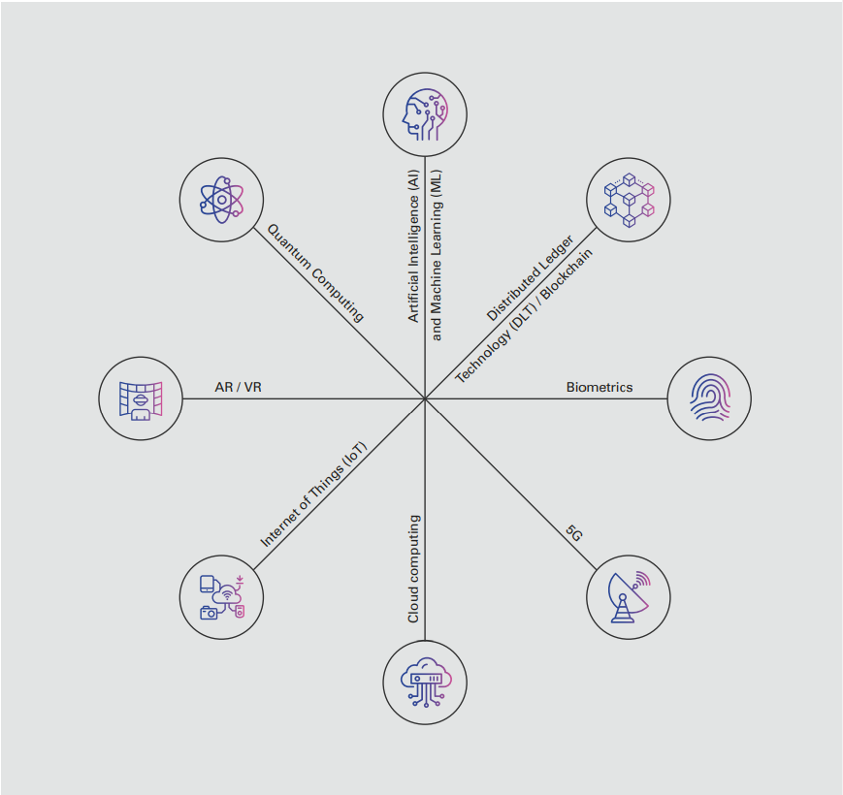

Source: The- future- of- digital- banking- KPMG-CBA-report (2019)

The Commonwealth Bank of Australia (CBA) is a market leader in the area of total market capitalisation, the Australian market in profitability, customer service and digital offerings. However, it has spectacularly failed when it has come to managing regulatory and reputational risk. In the past year, CBA faced an AUD 700 million (USD 500 million) settlement for 53,750 breaches of the Anti-Money Laundering and Counter-Terrorism Act, as well as a sarcastic report from the banking regulator on its risk and regulatory practices, the early resignation of its CEO and the scrutiny of a Royal Commission.

In the last decades, the explosion of the volume of digital document images and the development of consumer tools to forge these images has led to a huge increase in the number of corrupted documents in the financial sector. The development of many tools and methods to detect modifications has also increased but benchmarking remains a challenge. With all the benefits it comes with, development of technologies has also an important side effect. For instance, number of amateur fraudsters has increased. Actually, it is quite accessible for many people to scan any loan contractual documents (payslip, bill, mortgage deeds etc.), modify one or several critical field (name, date, amount of money, etc.) and print it with common devices and basic software’s (MS Paint, Gimp, etc.).

In recent years, fraud has been a significant issue in the banking, medical, insurance, and IT sectors. In the banking industry there has been an increase in online transactions through submitting required loan application documents such as payment slips, credit rating details, project reports, loan collaterals and etc. Similar risk of fraudulent activities increases in the fields of different payment options such as credit/debit cards, PhonePe, Gpay, Paytm, etc. Moreover, fraudsters have become proficient in finding loopholes that they then misuse. Hence it has become a challenging task to make a secure system for authentication and preventing fraud. This is where fraud detection algorithms powered by machine learning prove helpful.

When customers apply for larger loans and mortgages, they usually have to supply supporting documents to prove that they hold the sufficient wealth (assets) and receive the respective income they claim. The financial institution must verify that these documents are legitimate as one of the steps in granting the loan request. Machine learning and artificial intelligence tools can help the bank's fraud detection team focus on the most likely fraudulent documents - it would be impossible to examine them all thoroughly. These tools can also be adapted as the methods of the fraudsters change over time.

**Why CBA considered a fintech company?**

* Minimise frauds in the field of digital and online payment mechanism (credit/debit cards, PhonePe, Gpay, Paytm, etc), contractual loan documentation (payslip, bill, mortgage deeds, guarantor’s details documents etc.), Money Laundering and Terrorism funding, Phishing.
* Fintech companies provide the banks with access to new capabilities (e.g. products, experience design, processes, systems, people), in order to better serve customer needs.
* Fintech companies offer the banks a faster speed to market than in-house development provides
* They come with lower costs and investments, as transformation of legacy businesses isn’t required, and
* They reduce project delivery risks, given that they plug into existing businesses.
* Finally, Fintech company caused to maximise the overall of wealth to its stakeholders and economic wellbeing of the entire society.

**Why is CBA exemplary in the FinTech space? What are their strengths and weaknesses?**

Commonwealth Bank Chief Executive Officer, Matt Comyn, today announced that the Bank is accelerating its digital strategy with a motivation to provide customers with one of the best digital experiences of any company globally.

Speaking at CBA’s 2021 technology briefing at the Bank’s new tech hub at South Eveleigh in Sydney today, Mr Comyn said: “CBA wants to remain Australia’s clear leader in digital banking. We recognise customers are no longer just benchmarking us against other financial institutions. They compare us with the best digital experiences they get from any business in the world. We intend to be at the global forefront of the digital experience, and be the trusted partner at the centre of our customers’ financial lives.

CBA investment in technology including data, machine learning and artificial intelligence is giving us unique insights into each customer’s individual needs. Customers want more control over their financial affairs, more confidence they can achieve financial goals, and an ability to manage all of their financial life in one place. Today bank also announced that CBA has applied for accreditation to ingest data under the government’s Open Banking regime. The Consumer Data Right puts customers in control and will be a critical enabler of Australia’s future and the digital economy. CBA will continue to invest to support it and bring the benefits to CBA’s customers.

**CBA Strengths in FINTECH SPACE**

SWOT Analysis of Commonwealth Bank

SWOT analysis of Commonwealth Bank is the study of internal strengths, weaknesses, and external opportunities, and threats of the company. This will help the company understand strong factors for their growth, weakness, and threats to rectify them for further growth.

To better understand the SWOT analysis of Commonwealth Bank, refer to the infographics below:

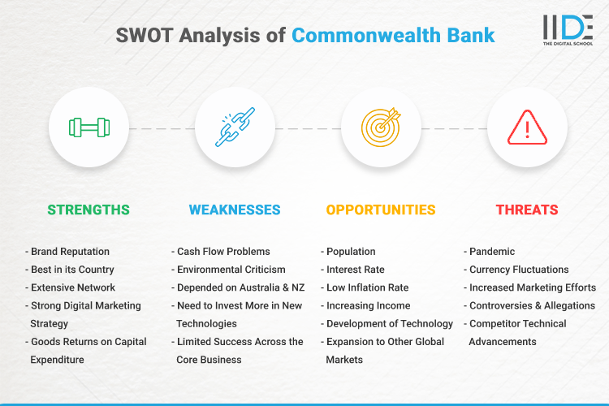

Source : https://iide.co/case-studies/swot-analysis-of-commonwealth-bank/

**CBA had perceived record numbers of customers banking digitally**

* 7.5 million customers are now digitally active, an increase of 10 per cent since December 2018.
* 6.3 million customers are using the CommBank app, as at December 2020, up from 5.9 million customers from the same time the year before.
* For the month of December 2020, the number of app log-ins was 216 million, which translated to 6.95 million log-ins per day.
* For the month of December 2020, app transactions per day were 1.7 million, equating to daily transactions of $1 billion.
* Over 6 billion personalised in-app messages were sent to customers in 2020.
* 731 million in-app messages were sent relating to COVID-19 support and information in 2020.
* The Benefits finder service in CommBank app and NetBank has helped customers find more than $150 million annually in federal and state financial benefits with 2.9 million customers visiting the feature since its September 2019 launch and 920,000 claims commenced, of which 615,000 were commenced since COVID-19 began.
* 6.4 million customers received crisis response messages in 2020 for incidents such as bushfires.
* CBA’s Biz Express product has been fast-tracked to help small businesses get immediate access to funding to support and grow their operations as the country looks to recover from the worst effects of the coronavirus pandemic. BizExpress Online is available via NetBank and the CommBank app providing real time decisions and funding of up to $100k for customers in as little as 12 minutes.

**CBA weaknesses in FINTECH SPACE**

* **Need to Invest More in New Technologies:** According to the country’s scale of expansion and the geographical areas Commonwealth Bank needs to invest more money in technology to integrate the processes across the board. Currently, the investment in technology is not on par as per the vision of the company.
* **Limited Success Across the Core Business:** Although Commonwealth Bank is one of the leading organizations in its industry it faces challenges in moving to other product segments with its present culture.
* **Cash Flow Problems:** There is a lack of proper financial planning at Commonwealth Bank regarding cash flows, leading to certain circumstances where there isn’t enough cash flow as required leading to unnecessary unplanned borrowing.
* **Environmental Criticism:** Commonwealth Bank has been criticized several times by environmental activists for financing oil sands extractions that cause negative effects on the environment and human health.
* **Competitor Technical Advancements:** New technological advancements by a few competitors within the sector constitutes a threat to Commonwealth Bank since customers who are drawn to this new technology may switch to competitors, reducing Commonwealth Bank’s overall market share.
* **Controversies & Allegations:** Commonwealth Bank has been in more than 10+ controversies including the 2008 financial planning scandal, money laundering scandal, Bank bill swap rate allegations and many more. Recently, Commonwealth Bank has been sued by an Indonesian family for launching fake money laundering scams.

**What is the prognosis for this company? Where do they expect to be in the future?**

Banking in 2030 CBA will become a trusted interface for life, embedded within the needs and lifestyles of consumers Delivery and experience re-defined by 2030 Data will underpin the delivery of seamless, integrated experiences that span beyond banking to anticipate and satisfy other customer needs. Data will be at the heart of how banks deliver new forms of value to customers and how they will make money in 2030 (in response to emerging consumer needs around their personal data). Setting banking within the consumers everyday needs, lifestyles and life-stages will be key - as will providing and creating financial services (and other services) to meet the immediate satisfaction of these demands.

**Everything and everyone will be connected**

By 2030 a hyper-connected world will be the norm. Consumers will be interacting with their service providers through voice and personal assistants, facial recognition and wearable devices. Every engagement point of our lives will become a service. CBA of the Future proactively switching your subscriptions with non-banking services because they found a better offer available than your current provider. This could include the management of utilities and services in your home. With usage patterns well known through smart meters, banks can analyse providers’ offers based on peak pricing and volume discounts, switching providers in the background as better deals become available. Conversely, entities from other sectors will also be trying to offer their customers the ability to optimise financial services.

**The rise of AI**

Algorithms and data models will be built around optimising financial outcomes for customers and will frequently strengthen positive behaviours through ‘nudging’ individuals to do certain things. For example, supporting sectors of the population that are time poor and are seeking greater convenience, as well as preventing susceptible customers from making poor financial decisions. These nudges will be universal, and not restricted to certain segments of customers.

**Distributed Trust**

The CBA of the Future will be able to lead the redefinition and pashion of trust, leveraging their heritage and experience to gain a distinct advantage over newer entrants. Through the delivery of services enabled by digital identity and DLT - customers can trust that the automation and decisions made on their behalf are noticeable, reconcilable and crystal clear to them. This will help consumers manage their increasingly complex and fragmented lives

**The ‘super-app’**

The quest to create a ‘super-app’ or virtual service that can combine digital confidence, privacy, access control and can enable products and services has significant implications, as it allows successful entities to keep customers within their ecosystems for nearly all their activities, and away from their competitors.

**Payments**

Intelligent payment financing facilities that dynamically assign rates, and extend context relevant credit linked to the transaction type and spend are presented to consumers as an extension of buy now, pay later services. Customers’ credit assessments will be far more holistic and will update in real-time, taking inputs such as lifestyle habits, purchase history and predictive analytics. Credit products will be far more tailored to an individual, providing customers with flexible repayment plans for each transaction while integrating rewards programs based on their credit rating. Transaction experiences will not differ between transferring between friends, or between continents. The biggest change is in the global B2C commerce space as consumers will be free to spend overseas with international merchants without incurring foreign exchange fees.

**AI-driven cyber security**

By 2030, CBA cyber security will be built around enterprise-wide predictive analytics, security susceptibility and threat recognition, all powered by AI. Imagine AI redefining the assessment of online security vulnerabilities as it identifies and remediates security issues in real-time, preventing hackers from exploiting vulnerabilities.

**Digital currencies**

The rise of digital currencies (and tokens) that will be issued by central banks and corporate players will further accelerate the transformation of products and services. This digitisation of money will bring greater financial inclusion overall, broader transparency and better real-time transaction processing and settlement.

**List of references**

CBA Annual Report 2021

The- future- of- digital- banking- KPMG-CBA-report (2019)

<http://www.commbank.com.au/>

<https://datanalysis-morningstar-com-au.ap1.proxy.openathens.net/af/company/annualreport/>

<https://www.fintechaustralia.org.au/>

<https://iide.co/case-studies/swot-analysis-of-commonwealth-bank/>